PL-2303 and PL-2303X USB to Serial Adapter
User Installation Manual

For Windows 98/ME/2000/XP
Release Version 1.1 (1/5/2004)

Contents
Introduction
Features & Specifications
System Requirements
Installing the Device
Uninstalling the Device
Disclaimer

Introduction
The PL-2303 USB to Serial adapter is your smart and convenient accessory for connecting RS-232 serial devices to your USB-equipped Windows host computer. It provides a bridge connection with a standard DB 9-pin male serial port connector in one end and a standard Type-A USB plug connector on the other end. You simply attach the serial device onto the serial port of the cable and plug the USB connector into your PC USB port. It allows a simple and easy way of adding serial connections to your PC without having to go thru inserting a serial card and traditional port configuration.

This USB to Serial adapter is ideal for connecting modems, cellular phones, PDAs, digital cameras, card readers and other serial devices to your computer. It provides serial connections up to 1Mbps of data transfer rate. And since USB does not require any IRQ resource, more devices can be attached to the system without the previous hassles of device and resource conflicts.

Finally, the PL-2303 USB to Serial adapter is a fully USB Specification compliant device and therefore supports advanced power management such as suspend and resume operations as well as remote wakeup. The PL-2303 USB Serial cable adapter is designed to work on all Windows operating systems.

Features & Specifications

- Smart USB to RS-232 (DB 9-pin male serial port) interface
- Supports various serial devices like modems, PDAs, cellular phones, digital cameras, card readers, and more.
- Easy Plug and Play Installation
- Full Compliance with the Universal Serial Bus Specification v1.1
- Supports the standard RS-232 Serial Interface
- Supports automatic handshake mode
- Over 1Mbps data transfer rate
- Supports Remote Wake-up and Intelligent Power Management
- Provides Dual Buffers for upstream and downstream data transfer
- No IRQ resource required
- Bus Powered – no separate power supply or battery required
- Dimensions L x W x H: _________ (mm)
- Weight: ____grams (approximate)

System Requirements
- Windows 98, Windows ME, Windows 2000, or Windows XP operating system
- AMD or Intel Pentium 133MHz or better based computer
- USB 1.1 or higher port
- USB to RS-232 (Serial Port) Cable Adapter
- USB to RS-232 Driver Utility Disk
Installing the Device with InstallShield
This section will guide you on how to install the PL-2303 USB to Serial adapter under Windows XP, Windows 2000, Windows ME, and Windows 98 operating systems.

Note: Please take notice of the installation order. First, run the InstallShield wizard, and then plug in the USB to Serial adapter.

The following steps will show how to install the device under Windows XP. Basically, the procedures are also somewhat the same for other Windows operating systems.

- Power on your computer and boot to Windows.

- Run or double-click the InstallShield driver setup program “PL-2303 Driver Installer.exe”. The InstallShield Wizard will be displayed on your screen to inform you that the PL-2303 USB-to-Serial driver will be installed on your computer. Click Next to continue and start the installation.

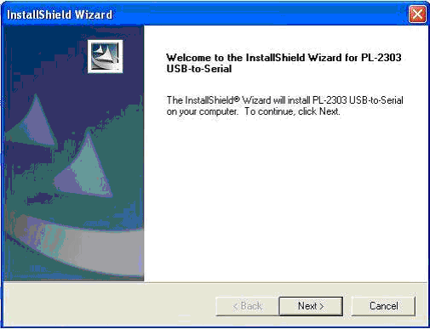

- Wait until the InstallShield Wizard informs you that driver installation is successfully installed. Click the Finish button to close the InstallShield program. If you have plugged the cable into the PC while running the setup installation, please unplug and replug the cable for the system to detect the device.

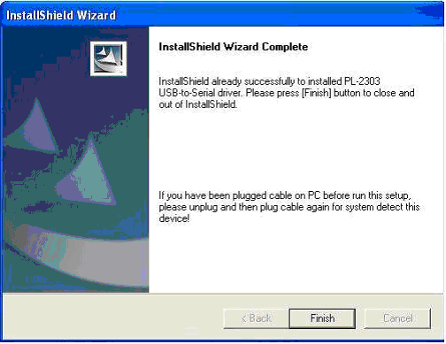

- Locate the USB port of your computer and plug in the USB to Serial adapter. Windows should detect the driver as Prolific USB-to-Serial Comm Port. Before Windows installs this, it may prompt you that this device driver has not yet passed Windows XP Logo compatibility. Click Continue Anyway. Windows will then start to install the driver for the USB-to-Serial Comm Port.

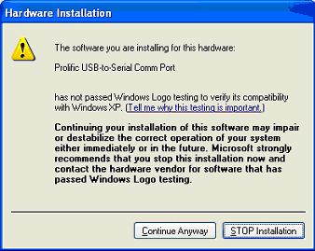
Uninstalling the Device Driver
It is easy to uninstall the USB to Serial device driver. You have three selections to uninstall the PL-2303 driver:

- Run the InstallShield Setup “PL-2303 Driver Installer.exe” program again
- Run Start → Programs → PL-2303 USB-Serial Driver → Uninstaller
- Control Panel → Add or Remove Programs → PL-2303 USB-to-Serial

- The InstallShield Wizard will appear and will let you choose if you want to reinstall the driver, uninstall the driver or exit the wizard. Select to Uninstall driver, and then click Next to continue.

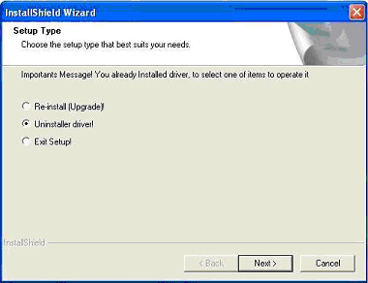

- When finished, the InstallShield Wizard will prompt you to restart Windows. Click the Finish button and wait for the system to restart your computer.

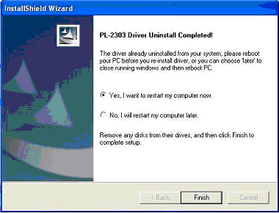

Disclaimer
Information in this document is subject to change without notice. The manufacturer does not make any representations or warranties (implied or otherwise) regarding the accuracy and completeness of this document and shall in no event be liable for any loss of profit or any other commercial damage, including but not limited to special, incidental, consequential, or other damages.

No part of this document may be reproduced or transmitted in any form by any means without the express written permission of the manufacturer.

All brand names and product names used in this document are trademarks or registered trademarks of their respective holders.

